Scholarships
Awarded

Delta Rice Queen
$2500
Delta Rice Ambassador
$2500

Dr. James Smith
Memorial Scholarships
1st Runner-Up Queen
$250
1st Runner-Up Ambassador
$250

4

Important Dates:
- September 13, 2024
Applications due
- September 17, 2024
Judges interview
- September 19, 2024
Delta Rice Festival
Revised 07/24

Contest applications, guidelines, rules, and regulations, and required forms are available at

deltaricepromotions.org

OR
Laura J. Giaccaglia
Bolivar County
MSU Extension Service
662-843-8362
l.j.giaccaglia@msstate.edu

2

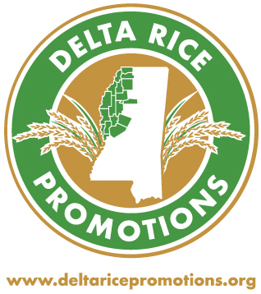

presents
The
Delta Rice
Scholarship
Contests

at the
34th annual
National Rice Month
Celebration
(Delta Rice Festival)
September 19, 2024
4:00-9:00 p.m.
Merigold, MS

For Graduating
High School Seniors
Delta Rice Promotions, Inc. is offering $2500 scholarships to a female (Queen Contest) graduating senior and a male (Ambassador Contest) graduating senior who attend school in a Delta rice producing county (Bolivar, Coahoma, DeSoto, Holmes, Humphreys, Issaquena, Leflore, Panola, Quitman, Sunflower, Tallahatchie, Tate, Tunica, and Washington).
In addition, each Runner-Up in both the Queen and Ambassador contest will receive a $250 Dr. James Smith Memorial Scholarship.

Judging is based on two criteria:
- A submitted written essay:
“The Importance of Rice to Mississippi’s Economy”, and
- An interview session and presentation based on the content from the submitted essay.

The essay should be no more than 300 words in length (single-spaced, Times New Roman font no smaller than 11). Correct grammar is essential.
There will be an in-person interview with the judges in which the contestants will give their presentation on “The Importance of Rice to Mississippi’s Economy.” Visual aids, including Power Points, are encouraged. However, judges’ gifts are not acceptable. Following the oral presentation, judges will ask contestants questions taken from their essay and oral presentation.
Interviews may be recorded for later judging, if needed.

Entry form, essay, contestant’s photograph, supporting documents and
The Delta Rice Queen and Delta Rice Ambassador and the Runners-Up were announced at the 2023 Delta Rice Festival held in Merigold on September 21st.
Pictured (from left to right) are the 2023 Delta Rice Queen, Keeton Murrell; Runner-Up, Leah Walker; Runner-Up Delta Rice Ambassador, Mac Sullivan, and the 2023 Delta Rice Ambassador, Holt Fortner.

*SPONSORSHIP CHECK*
should be mailed to
Deniese Swindoll
1045 Morrow Crest Dr.
Hernando, MS 38632
AND emailed to
MSUMom57@yahoo.com
2024 Delta Rice Festival
September 19, 2024
4-9 p.m.
ALL are due on or before
September 13, 2024

2023
Delta Rice Queen &
Delta Rice Ambassador
Contest

